Image Processing for Production Line Rejection Manager System

Author: Costantinos Constantinou

Purpose of project: The project aims to develop an automatized production line reject management system to perform product inspection and ensure the packaging condition is in line with the manufacturer’s specification and ready for deployment to the market.

Keywords: OpenCV API, Python, Machine Vision, Rejection Manager System

Brief:
The solution for this production line reject manager system is developed in Python with the use of the OpenCV API libraries. OpenCV offers an extensive range of libraries to enable machine vision in industrial process control. This project uses machine vision techniques and aims to enhance the performance of the production line visual inspections and increase the productivity via the autonomous reject management system.

Execution:
The main components of this machine vision solution are colour thresholding, edge detection and SIFT (Scale-Invariant-Feature-Transform) algorithm.
For instance, figure 1 shows a product model which is studied for component detection. In this case, the lid of the plastic bottle is identified using colour thresholding and applying a mask filter. The mask filter is then used to detect and draw the contours on the image to highlight the detected component.
The result of the mask and the component highlighted is performed in Python with OpenCV libraries and it is shown in figure 2.
The first row of images in figure 2, shows the lid of the plastic bottle being in the correct position detected by the machine vision algorithm.
In the second row we see that with the lid missing, the algorithm detects the mask of the missing component and highlights the position of the component on the original picture.
With this method, contours are drawn around the component to detect if a component is missing or not. Figure 1 shows the contour of the lid component on the original image.
The contour is enclosed within a rectangle, making it clear that the component is detected. By using the contours area and by comparison considering set-points of sensitivity, the algorithm can tell whether a product has a faulty/missing component/ layer.
The faulty product is acknowledged by the algorithm and the reject manager rejects the product from the production line.
Figure 2. Result of component detection and masking.
Figure 1. Product model
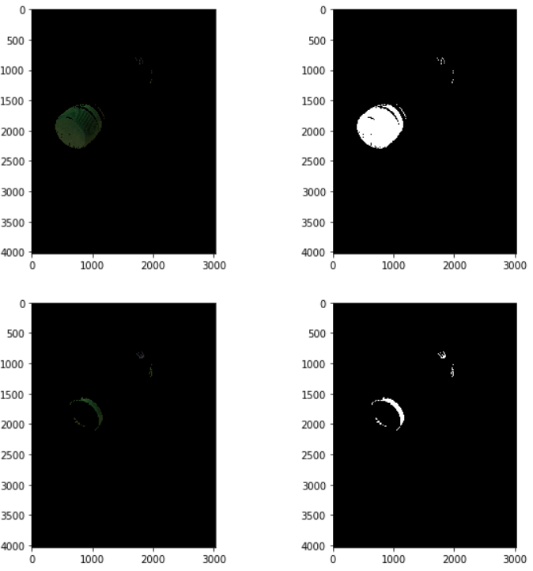
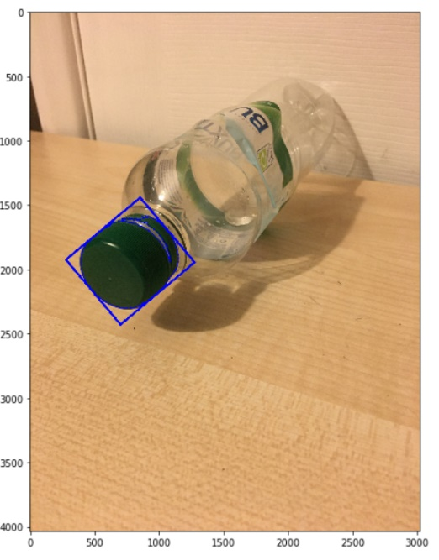

Even though the example we have just seen in performed on a static image, we will see below the application on a real production line.

Applying computer vision on production line:
In the scenario where a continuous moving production line is present, a camera system needs to be established to monitor the products. The cameras can be positioned at multiple points to perform cross-checking and ensure the good condition of products throughout the production line.
As a camera system is involved, the computer vision is upgraded with further techniques to capture the frames of the images through the camera and perform the analysis only on the relevant sections.
This is no different than what a human logic would be to inspect the individual products. This means, the algorithm pauses the camera frames which include only the inspected product and ignores the background noise; e.g the transition frames between products.
In this example the machine vision solution applies successfully edge detection in combination with the SIFT algorithm to achieve product inspection.
The product in figure 3 is inspected with applying contour detection at the labels of interest to identify where the package meets the manufacturer’s specification before its release to the market. The algorithm shows a message “GOOD” for a good package detection.
If a package is detected as faulty with labels mismatching the specification the algorithm detects this and shows a “FAULT” message. The package is then rejected from the production line for further inspection. Examples of fault detection are shown in figures 4,5,6.
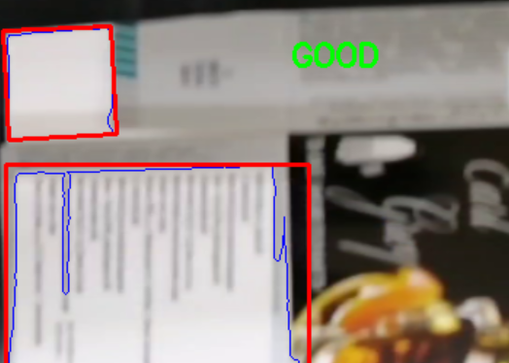  Figure 3. Good product detected on production line. | 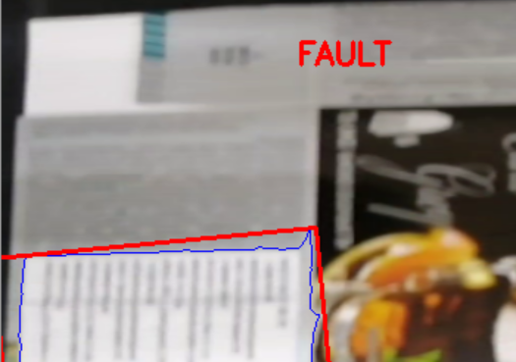  Figure 4. Faulty package detected on production line.
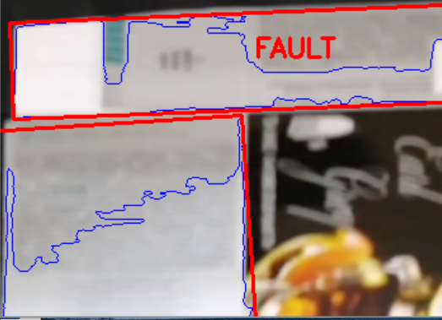  Figure 5. Faulty package detected on production line. | 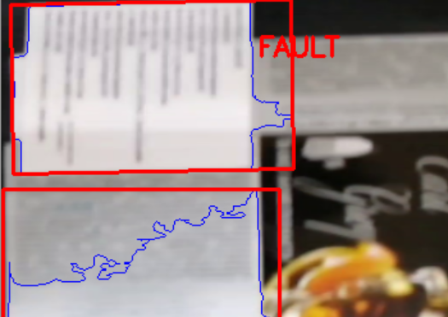  Figure 6. Faulty package detected on production line.

Machine vision revolutionizes the industrial processes. The core benefits in the manufacturing sector are:
- Reduce human error or repetitive motion injuries in a complicated manufacturing environment
- Enhance production speed, accuracy and increase of produced quantities
- Provide the information for diagnostic tools and predictive maintenance
- Achieve reduction in waste in manufacturing and packaging
- Achieve good ROI (return-on-investment) by increasing productivity, limiting waste and securing consumer satisfaction.

